Cox Internet Tools
This section is for those of you using Cox Cable for your internet provider. Becoming familiar with the Cox website and the internet tools and options provided will enable you to make the most use out of the service. You need your user name and password to log on to your account. Your user name is usually your email with Cox.
To access the Cox site enter the following in the web address space: http://westernarkansas.cox.net/cci/home
Enter your username and password in the labeled boxes and click the “Login” button.

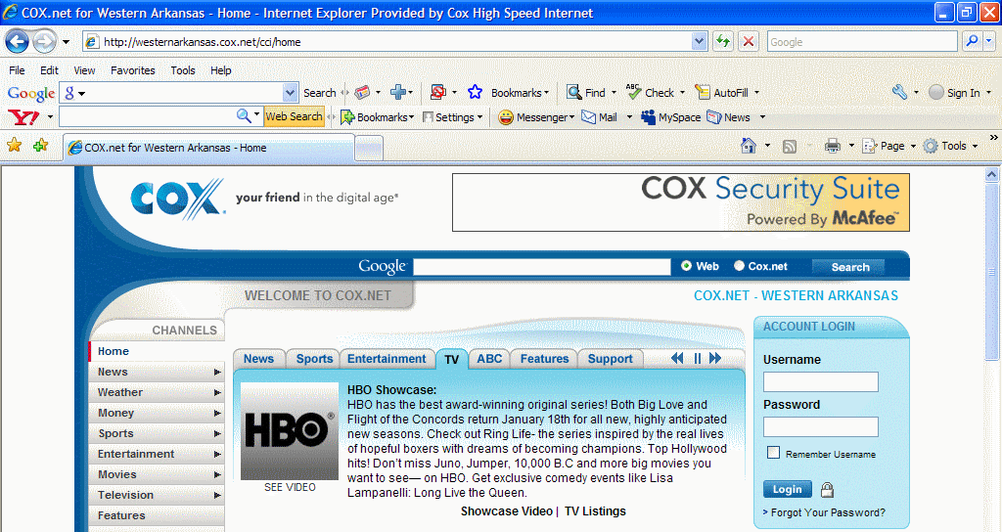

The Welcome Page allows you to choose the service you wish to access. It’s on the menu bar on the left side of the page under the “My Account” heading.

Click on the “Internet Tools” tab and review the options under “Account Management” and “Customer Support”.
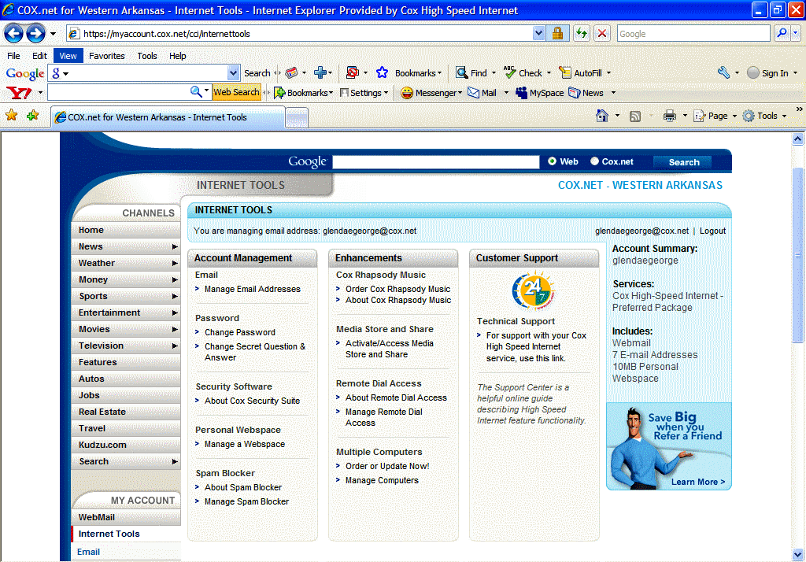

Click on the phrase “For support with your Cox High Speed Internet service, use this link” under Technical Support heading in the Customer Support column.

The following page will appear:

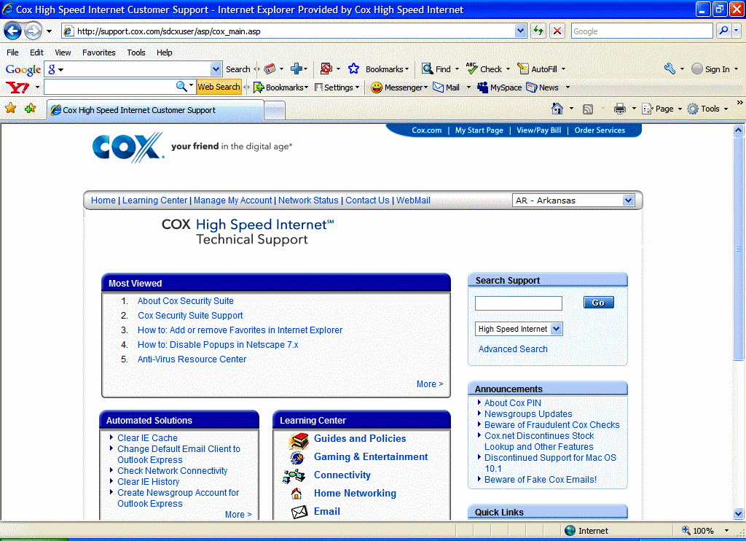

Click on the Number 1 topic “About Cox Security Suite”.

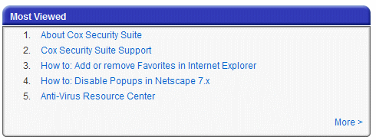

The following page will appear:
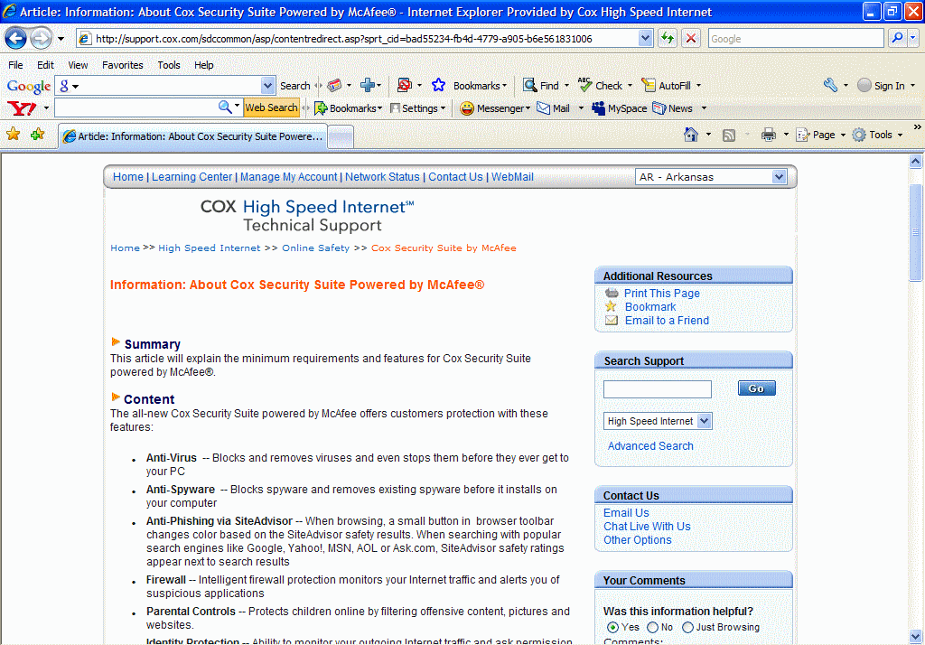

The following includes the detailed text explaining the Cox Security Suite, powered by McAfee:

COX High Speed InternetSM Technical Support

Information: About Cox Security Suite Powered by McAfee®

Summary
This article will explain the minimum requirements and features for Cox Security Suite powered by McAfee®.

Content
The all-new Cox Security Suite powered by McAfee offers customers protection with these features:
- Anti-Virus -- Blocks and removes viruses and even stops them before they ever get to your PC
- Anti-Spyware -- Blocks spyware and removes existing spyware before it installs on your computer
- Anti-Phishing via SiteAdvisor -- When browsing, a small button in browser toolbar changes color based on the SiteAdvisor safety results. When searching with popular search engines like Google, Yahoo!, MSN, AOL or Ask.com, SiteAdvisor safety ratings appear next to search results
- Firewall -- Intelligent firewall protection monitors your Internet traffic and alerts you of suspicious applications
- Parental Controls -- Protects children online by filtering offensive content, pictures and websites.
- Identity Protection -- Ability to monitor your outgoing Internet traffic and ask permission before personal information -- including PINs, bank accounts, SSNs and family names -- are sent from your PC

The following are the requirements necessary to run Cox Security Suite powered by McAfee:
Eligibility Requirements
- Be the primary account holder
- Have an active Cox High Speed Internet account in good standing
- Have an Internet Tools login and password
Minimum System Requirements for Cox Security Suite
- Microsoft® Windows 2000® (32-bit) with Service Pack 4 (SP4) or later
- Windows XP (32-bit) with Service Pack 1 (SP1) or later
- Windows Vista™ (32 or 64-bit) with Windows Vista Service Pack (SP1) or later
- Personal computer with Pentium-compatible processor 500 MHz or higher and 256 MB RAM or higher
- 800 X 600 or higher resolution
- 75 MB hard disk space
- Internet connection
- Microsoft® Internet Explorer 6.0 or later
- Optional: Mozilla® Firefox® 1.5 or later
Note to Apple users: The Cox Security Suite is not compatible with MAC OS software. For more information on securing your Apple computer, visit Apple Security.
Important: Cox Security Suite software will not install if existing virus scanning software or firewalls are already active on the computer
Email programs compatible with Cox Security Suite
MAPI
- Outlook®
POP3
- Outlook Express®
- Outlook
- Windows Mail®
- Eudora™
- Netscape®
- Thunderbird
- IncrediMail
- Shuriken
- Becky
- PostPet™ (Japanese only)
Web
- MSN/Hotmail
- Webmail account with POP3 access
Important: Cox provides application support for Outlook Express only.
Instant Messenge Programs compatible with Cox Security Suite
- AOL® Instant Messenger™ 2.1 or later
- Yahoo® Messenger 4.1 or later
- Microsoft Windows Messenger 3.6 or later
- MSN Messenger 6.0 or later
Customer Support
For more information on Cox Security Suite powered by McAfee, review the Cox Security Suite User Guide. You can also visit http://cox.mcafee.com to access the McAfee Technical Support site where you can select from the following support options:
- McAfee Virtual Technician
- McAfee Knowledge Center with FAQs and Search
- McAfee Chat and Email
Note: Due to the ever-changing nature of viruses and spyware, Cox Security Suite does not guarantee prevention or removal of all viruses and spyware. Only open files and messages from people and sites you trust.
Frequently Asked Questions
What is different about Cox Security Suite Powered by McAfee 2009?
The updated Cox Security Suite offers even more features to help protect consumers against a wide variety of computer and Internet threats with McAfee managed services. These include Active Protection that provides instant threat updates; Quick Scan, which allows you to check for threats in vulnerable areas; McAfee Secure, which protects against identity theft and credit fraud while you shop online; and Age Appropriate Searching, so that parents can automatically set proper content filters of popular search engines for each member of the household.
How do I get Cox Security Suite?
Log onto Internet Tools on Cox.net with your username and password. Click the Security Suite link and follow the simple on-screen instructions.

How much does the Cox Security Suite cost?
It’s free for all Cox High Speed Internet customers.
What about customers who are currently paying Cox for the McAfee products?
If they have been paying Cox for McAfee features, these will now be displayed on their bill as “now free.” The only exception is for SpamKiller: customers who choose to continue that service will still be billed $3.49 per month, as SpamKiller is not part of the new Cox Security Suite powered by McAfee.
Which McAfee products will be available free of charge?
McAfee VirusScan Plus, McAfee PrivacyService, and McAfee SiteAdvisor. These include: VirusScan Plus: anti-virus, anti-spyware and personal firewall protection; PrivacyService: identity theft protection and parental controls; SiteAdvisor: adds a safety rating to sites and search engine results to help avoid online dangers.
Can I choose to download only portions of the Cox Security Suite (such as, I only want virus protection but not parental controls)?
Yes. We certainly recommend you take advantage of all three McAfee products, but you will have the option to select, customize, and download the components you want.
Will Cox offer all CHSI customers the Cox Security Suite powered by McAfee?
Yes

I am having trouble with the Cox Security Suite. How can I get help?
Customers may continue to call Cox for support of Cox Security Suite powered by McAfee. In addition, Cox and McAfee have set up a special website, http://cox.mcafee.com which contains a variety of resources to help answer questions. Online support will include McAfee’s Virtual Technician, frequently asked questions and a knowledge base that includes email and chat support.
Will the Cox Security Suite powered by McAfee be available to CHSI Mac users?
Not at this time.
Will customers be limited to a certain number of PCs with the new Cox branded McAfee Security Suite?
Yes. CHSI subscribers will be limited to three PCs per account.
What if I purchased the McAfee Security Suite at the store? Can I still get the Cox Security Suite?

Now click the back button and then click on the Number 2 option:

The following page will appear and provide you with the opportunity to download McAfee:

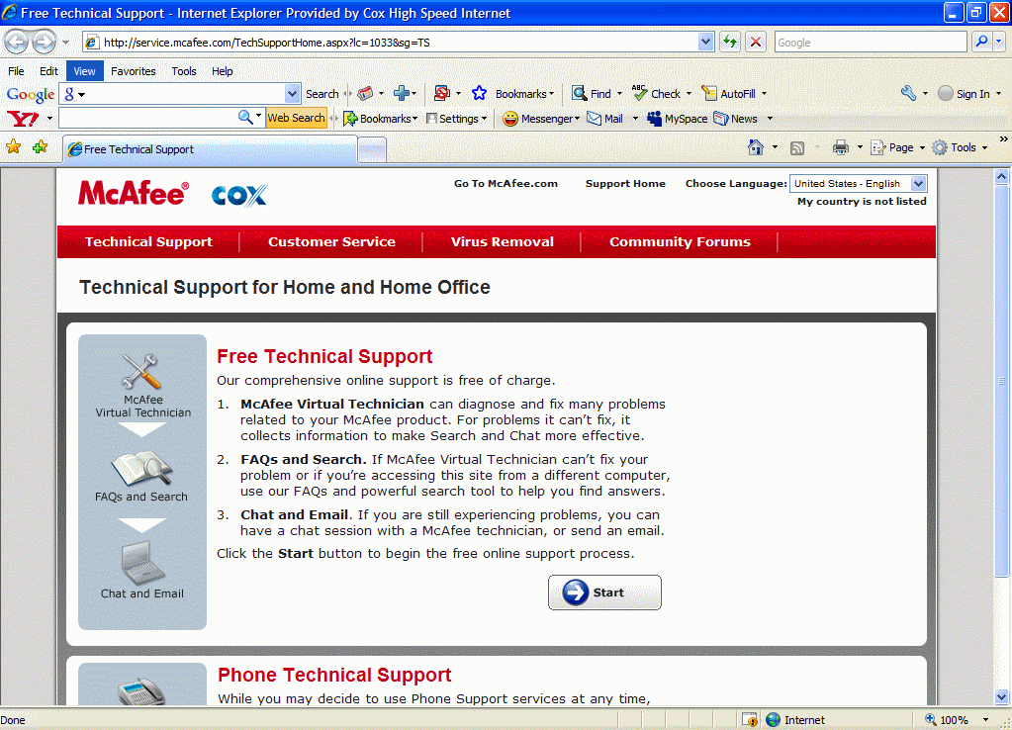

Close out of the above screen and return to the Technical Support page. It offers more help in the “Learning Center” section:
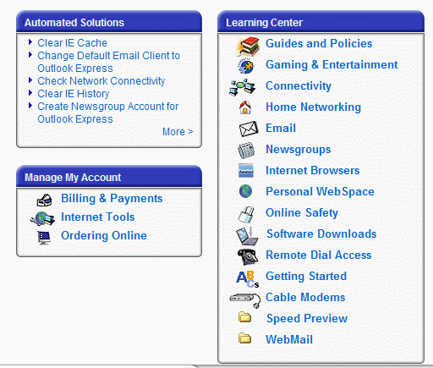

Click on the Email topic and the following page appears:

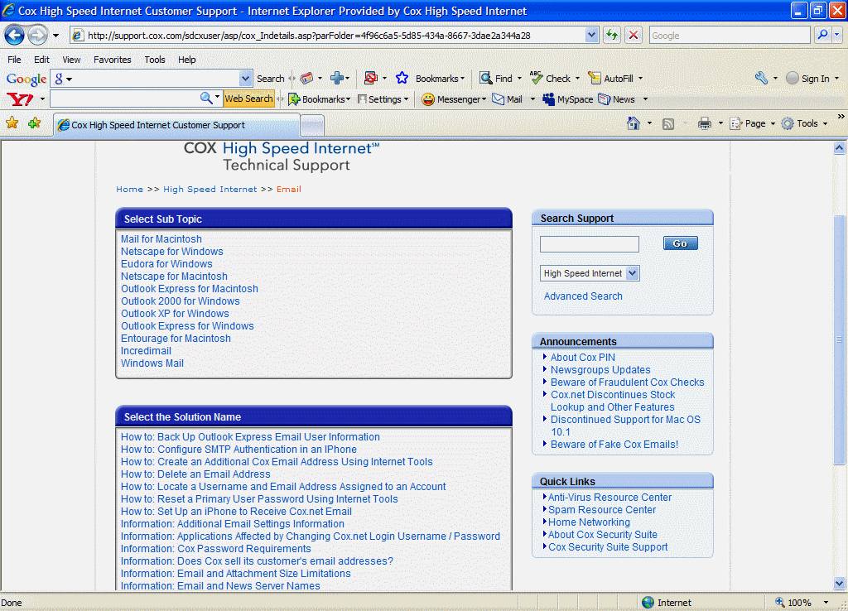

Click on the following topic:
The following page appears and provides several areas of help with Outlook Express:
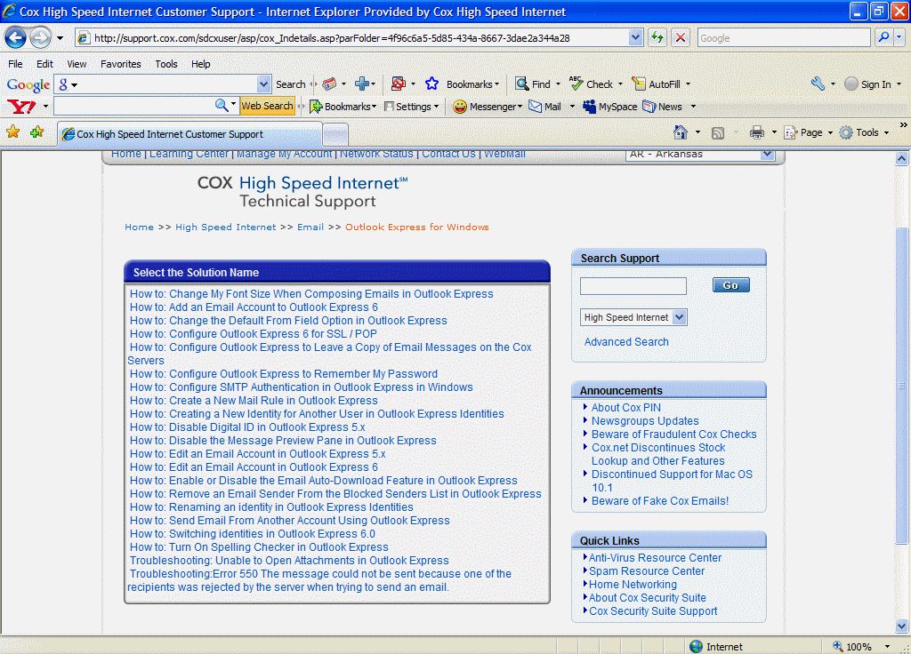

Now take some time and explore the tools offered by the Cox web site, including retrieving your email when you are away from your home computer.

